**National University of Computer and Emerging Sciences**



Laboratory Manual 08

for

Data Structures Lab

|  |  |
| --- | --- |
| Course Instructor | Ms. Syeda Tayyaba Bukhari |
| Lab Instructor(s) | Ms. Fariha Maqbool |
| Section | BDS-3A |
| Semester | Fall 2022 |

**Department of Computer Science**

FAST-NU, Lahore, Pakistan

**Objectives:**

In this lab, students will practice:

* Binary Trees
* Binary Search Tree
  + Insertion
  + Deletion
  + Traversal
  + Basic Operations

Implement a Binary Search Tree and implement the functions described in each task.

**Task 1:**

Implement a recursive function which should insert nodes in BST considering the following rules of BST:

1. All nodes of left subtree are less than the root node
2. All nodes of right subtree are more than the root node

bool insert(int d)

If the data already exists in the BST, this function simply returns false and true otherwise

**Example:** Insert 5

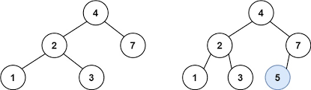

**Task 2:**

Create a function “inorderPrint” which prints the keys using in-order traversal.

void inorderPrint ()

**Example:**

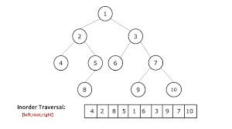



**Task 3:**

Create a function which returns the height of BST

int height()

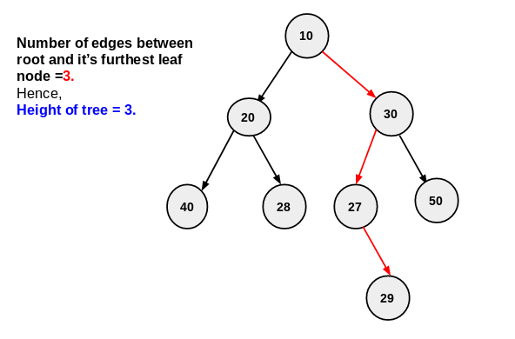

**Task 4:**

Implement a function “length” which uses recursion to return the count of total nodes in BST

int length() const

**Task 5:**

Create a function “search” which receives a key (data) as parameter. The function then uses recursion to return pointer to the corresponding node containing data. If the key does not exist, the function returns nullptr.

Node* search(int key)

**Task 6:**

Create a “deleteKey” function which is passed as parameter a key. The function then uses recursion to delete the node that contains that key.

void deleteKey(int key)